# Mental Health Management system (Naaman) use case

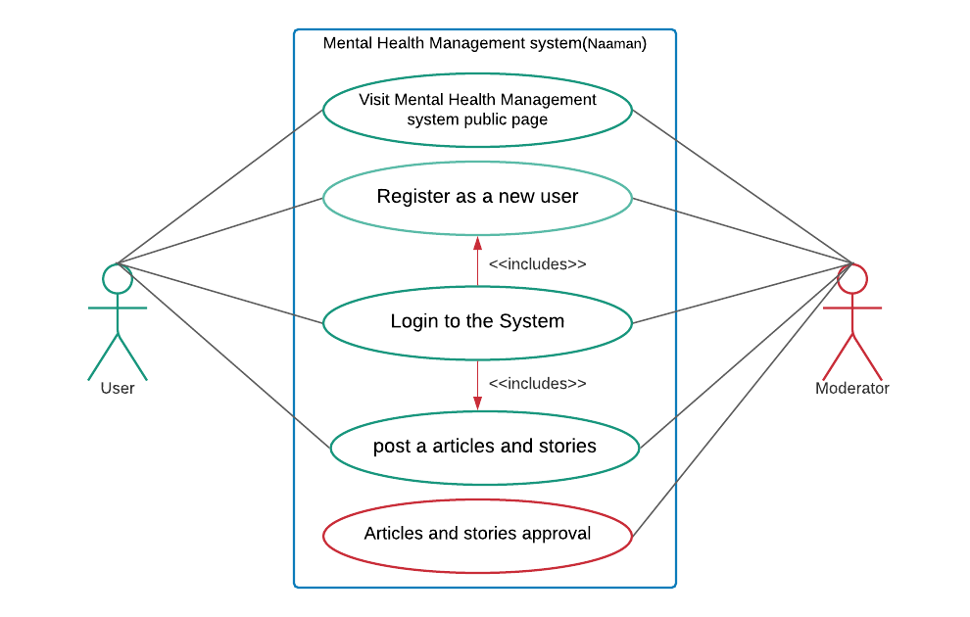

# Use-Case: <Access the web >

1 Brief Description

This use case allows to access the Remote Mental Health Management system public webpage for the user.

2 Actors

2.1 User

2.2 System

3 Pre-Conditions

* 1. The user must be a new user or have not logged in to the system

3.2 Website must be online

4 Normal Flow

The use case begins when user access web browser

|  |  |
| --- | --- |
| Actor | System |
| user request the Remote Mental Health Management system over the web browser | **1** check the request and confirm user status (if user has not logged into the session)  **2** create and send the related content over the website for the user. |

The use case ends.

5 Alternate Flows

if the user is register to the system and user logout the system

|  |  |
| --- | --- |
| Actor | System |
| request logout the system | **1** destroy the current login session  **2** create and send the related content over the website for the user. |

6 Sub flows

Request with wrong web address

|  |  |
| --- | --- |
| Actor | System |
| if user request is not correct | **1** check the request and confirm user status (if user has not logged into the session)  **3** if main domain is correct, redirect website main public page (home page with articles)  **2** create and send the related content over the website for the user. |

7 Key Scenarios

New and registered users visit this web page first. if user is new system generate website content using his geological location data. if user is currently registered, using his past data for generating the website content.

8 post-conditions

Add new record in to the user log with login IP address

9 Special Requirements

9.1 Minimum loading time

9.2 Mental Health Management System Security

9.3 UI and UX

9.4Language support

# Use-Case: < Register New User>

1 Brief Description

This use case allows to register new user into the Mental Health Management system

2 Actors

2.1 User

2.2 System

3 Pre-Conditions

3.1 The user must be new user

* 1. Website must be online

4 Normal Flow

The use case begins when user access web page (home page)

|  |  |
| --- | --- |
| Actor | System |
| **1** user request the Remote Mental Health Management system over the web browser | **2** check the request and confirm user status (if user has not logged session)  **3** create and send the related content over the website for the user. |
| **4** user request new registration | **5** The system generates a register form and an image with 4 random rotated letters. |
| **6** The user fills the text of their message, their full name and email. Next, they rewrite the text from the image into the appropriate field and submit the register form. | **7** The system validates the user data and stores the user data  **8** System send email to the user with register confirmation |
| **9** user confirms the email | **10** System create new login for the requested user |

The use case ends.

5 Alternate Flows

if new user visits the website and try to comment, make a post or other tasks.

|  |  |
| --- | --- |
| Actor | System |
| **1** User request a task (comment, share post or story) | **2** check the user session. if user session not in current register user list, system sends new user register form to the user |
| **3** The user fills the text of their message, their full name and email. Next, they rewrite the text from the image into the appropriate field and submit the register form. | **4** The system validates the user data and stores the user data  **5** System send email to the user with register confirmation |
| **6** user confirms the email | **7** System create new login for the requested user |

6 Sub flows

User doesn't complete and submit new user register form

|  |  |
| --- | --- |
| Actor | System |
| 1 User submit incomplete register form | **2** System starts the validation process and request correct data from the user (the register process restart) |

7 Key Scenarios

There are two main types of new user registration process. One is the user request for the registration process and the other is the system request registration process for the user. The system makes such a request when the user tries to perform a task on the system without signing in.

8 post-conditions

8.1 Store new user details and new login details

8.2 start new temporary session for the new user and update home page

9 Special Requirements

9.1 Minimum loading time

9.2 Mental Health Management System Security

9.3 UI and UX

9.4Language support

# Use-Case: < User Login>

1 Brief Description

This use case allows to login user in the Mental Health Management system

2 Actors

2.1 User

2.2 System

3 Pre-Conditions

3.1 The user must be register user

3.2 Website must be online

4 Normal Flow

The use case begins when user access web browser

|  |  |
| --- | --- |
| Actor | System |
| **1** user request the Remote Mental Health Management system over the web browser | **2** check the request and confirm user status (if user has not logged session)  **3** create and send the related content over the website for the user. |
| **4** user requests the login page | **5** system send the login page to the user |
| **6** users enter login details | **7** System start the validation process.  **8** if user-entered login details correct, system reload the page and set the user session. |

The use case ends.

5 Alternate Flows

user-entered login details incorrect

|  |  |
| --- | --- |
| Actor | System |
| **1** user enter login details | **2** System start the validation process.  **3** if user-entered login details incorrect, System send notification to the user about current status. and count user attempt |
| **3** user restarts the login process |  |

6 Sub flows

Exceeding user login attempt limit

|  |  |
| --- | --- |
| Actor | System |
| 1 Exceeding user login attempt limit | **2** Disable selected user logins and send email to the user. additionally show notification to the user about situation |

7 Key Scenarios

There are two main types of user login process. One is the user request for the login process and the other is the system request login process for the user. The system makes such a request when the user tries to perform a task on the system without sign in. system check the user session-log and identified registered-user. after system ask logging details for the user.

8 post-conditions

8.1 add record for the log-details

8.2 start new temporary session for the new user and update home page

9 Special Requirements

9.1 Minimum loading time

9.2 Mental Health Management System Security

9.3 UI and UX

9.4Language support

# Use-Case: < post article, story or Comment>

1 Brief Description

This use case allows to post an article, post a story, or comment an article of the Mental Health Management system

2 Actors

2.1 User

* 1. System

3 Pre-Conditions

3.1The user must be a registered user

3.2 Website must be online

4 Normal Flow

The use case begins when user logged into the System

|  |  |
| --- | --- |
| Actor | System |
| **1** user request the task (post article, stories or comments) | **2** System start the validation process.  **3** if user session is active, system give permission for the task |
| **4** users do the task (post or comment) | **5** system ask privacy level |
| **6** user defines the privacy level | **7** system store the data and send notification to the user.  **8** send task to the moderator |

The use case ends.

5 Key Scenarios

These are the main function of the Remote Mental Health Management system public page. These are used to share ideas with users. Here the user comments and performs other functions under some control.

6 post-conditions

6.1 add record for the log-details

6.2 The new story, article, comment will be stored correctly in the database with privacy limit in the task.

7 Special Requirements

7.1 Minimum loading time

7.2 Mental Health Management System Security

7.3 UI and UX

7.4Language support

# Use-Case: < Post and comment Approval process >

1 Brief Description

This use case allows approval to the user task of the Mental Health Management system

2 Actors

2.1 Moderator

* 1. System

3 Pre-Conditions

3.1 The moderator must be login

3.2 Website must be online

4 Normal Flow

The use case begins when user log the System

|  |  |
| --- | --- |
| Actor | System |
| **1** check the user task | **7** system shows the user task to the moderator |
| **4** moderator gives to permission for the user task (if post and comment under the rules and condition) | **5** system start to publish the user task in Remote Mental Health Management system public page  **6** the system send notification to the customer about task (post or comment) approval |

The use case ends.

5 Key Scenarios

This use case is described about user added post and comment approval process. Users come in different ways. therefore, system needs to control the activity. because, some users try to break the rules and regulation, it will be affected for the website quality. This approval function avoids that kind of things in system.

6 post-conditions

6.1 add record for the log-details

6.2 The system start to publish user added post or comment in the public page

7 Special Requirements

7.1 Minimum loading time

7.2 Mental Health Management System Security

7.3 UI and UX

7.4 Language support

# **Mental Health Management system (Naaman) private page (online consultation booking)**

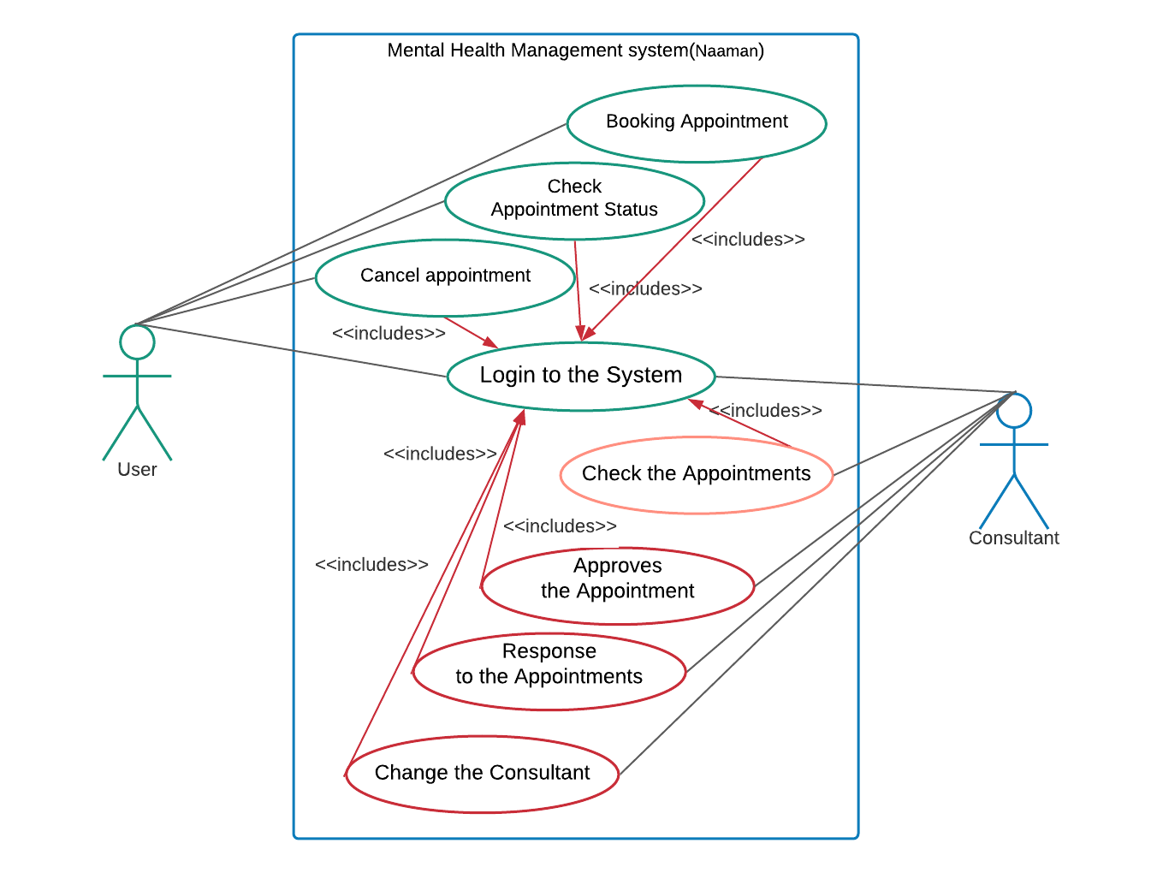

# Use-Case: <Make Private Appointment>

1 Brief Description

This use case allows to access the Remote Mental Health Management system to make private appointment for the user.

2 Actors

2.1 User

2.2 System

3 Pre-Conditions

3.1 The user must be a registered user

3.2 Website must be online

4 Normal Flow

The use case begins when user logged into the System

|  |  |
| --- | --- |
| Actor | System |
| **1** User requests to make private appointment for the consulting. | **2** system sends appointment-make form. |
| **3** User enter required data and submit the form. | **4** The system checks the available date and time  **5** The system shows the available date and time for the user |
| **6** User select date and time | **7** the System request a confirmation from user. |
| **8** User give the confirmation | **9** System store the new appointment |

The use case ends.

5 Alternate Flows

The Mental Health Management system check the user behaviours and suggest the private appointment to user for the consultation

|  |  |
| --- | --- |
| Actor | System |
|  | **1** the Mental Health Management system send email to the user explain benefits about consulting |
| **2** if user like to make appointment, user click the link in email | **3** the system navigate user to the appointment form  **4** system sends appointment-make form. |
| **5** User enter required data and submit the form. | **6** The system checks the available date and time  **7** The system shows the available date and time for the user |
| **8** User select date and time | **9** the System request a confirmation from user. |
| **10** User give the confirmation | **11** System store the new appointment |

6 Sub flows

user cancels the appointment before confirmation

|  |  |
| --- | --- |
| Actor | System |
|  | **1** system asks user about appointment condition (remove or add to the draft) |
| **2** User select draft | **3** The system stores theappointment as a draft appointment |

7 Key Scenarios

This is the Mental Health Management system private section. in this section can make appointment to the user for meet a consultant. if user need specialist about Mental Health, user can use this part for the meet a specialist.

8 post-conditions

8.1 Store the new appointment

8.2 Redirect web page for the home page

8.3 Show notification to the use about appointment details

9 Special Requirements

9.1 Minimum loading time

9.2 Mental Health Management System Security

9.3 UI and UX

9.4Language support

# Use-Case: < View user's Appointment>

1 Brief Description

This use case allows consultants to view the user made appointment

2 Actors

2.1 Consultant

2.2 System

3 Pre-Conditions

3.1 The moderator must be login

3.2 Website must be online

4 Normal Flow

The use case begins when user logged into the System

|  |  |
| --- | --- |
| Actor | System |
| **1** Consultant requests to view the user's made appointment list | **2** System shows the appointment |
| **3** Consultant is selecting the related appointment and check the date and time  **4** Consultant is making approval to the selected appointment | **5** System store the approval  **6** system send notification to the user about the appointment approval. |

The use case ends.

5 Key Scenarios

this use case allows the Consultant view the appointment and confirm. after confirmation, system will send the notification to the user about the situation. in that notification will have Consultant name and other details. after receiving conformation, user can ready to consulting.

6 post-conditions

6.1 add record for the log-details

* 1. The system is sending notification and email to the user

7 Special Requirements

7.1 Minimum loading time

7.2 Mental Health Management System Security

7.3 UI and UX

7.4 Language support